**9a. Develop a JPA Application to demonstrate use of ORM associations.**

**OR**

**9b. Develop a Hibernate application to store Feedback of Website Visitor in MySQL Database**

**MySql Queries:**

CREATE DATABASE GuestBook;

USE GuestBook;

CREATE TABLE GuestBook(

VisitorNo Int PRIMARY KEY AUTO_INCREMENT,

VisitorName varchar(50),

Message varchar(100),

MessageDate varchar(40));

**Add the following jars:**

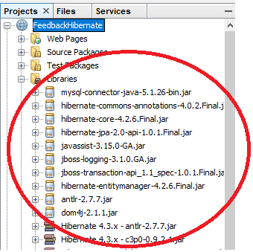

**Create the hibernate.cfg.xml file by following the steps given below**

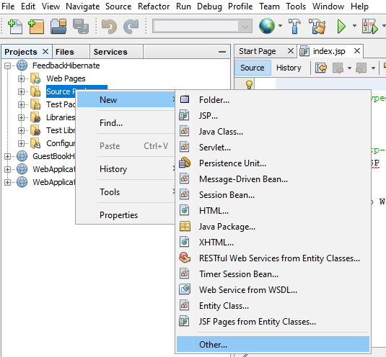

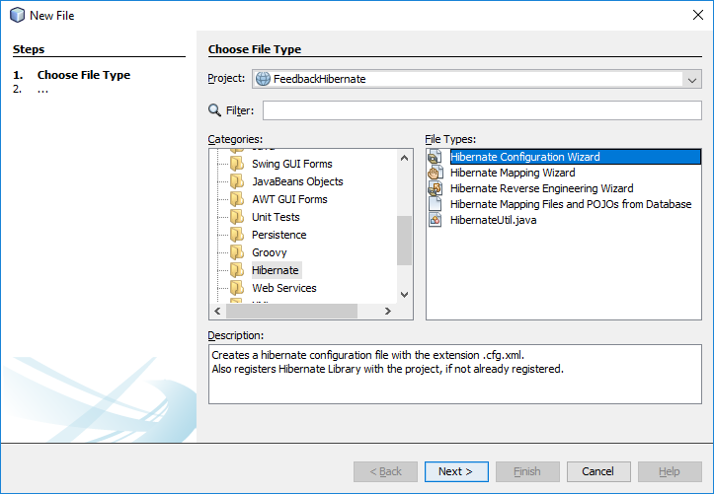

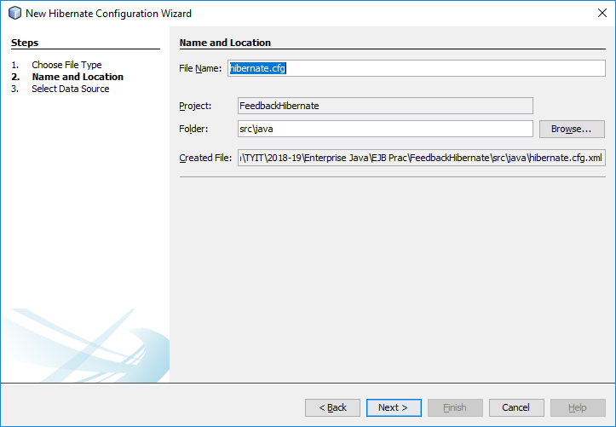

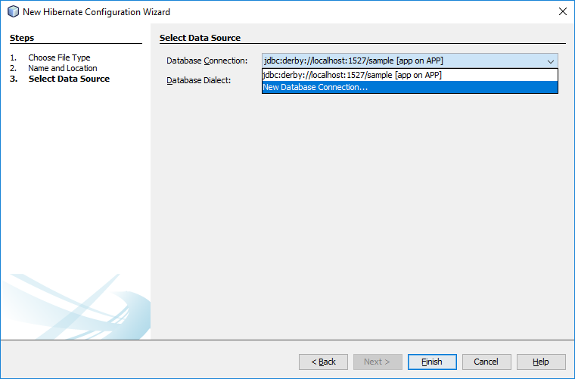

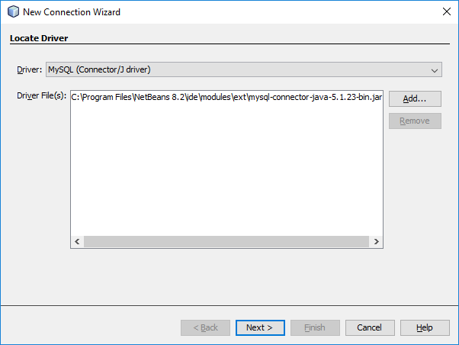

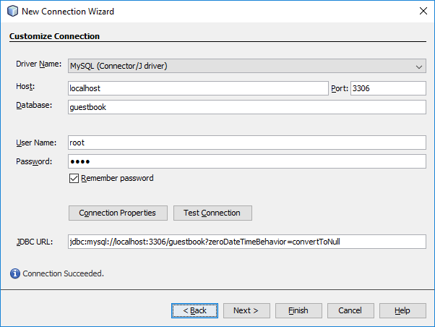

**Then click “finish”**

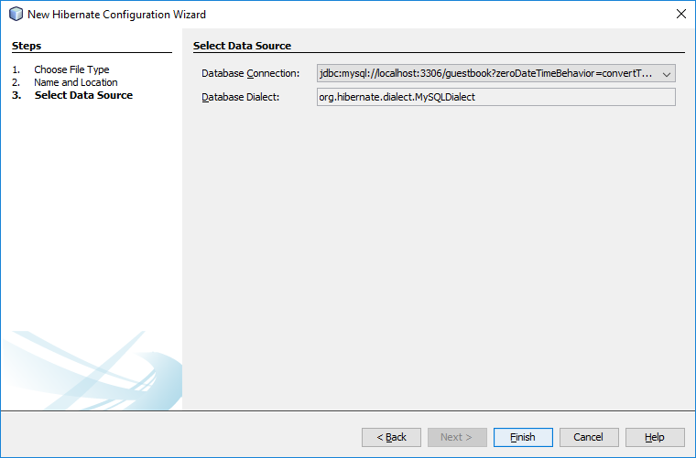

**Then click “finish”**

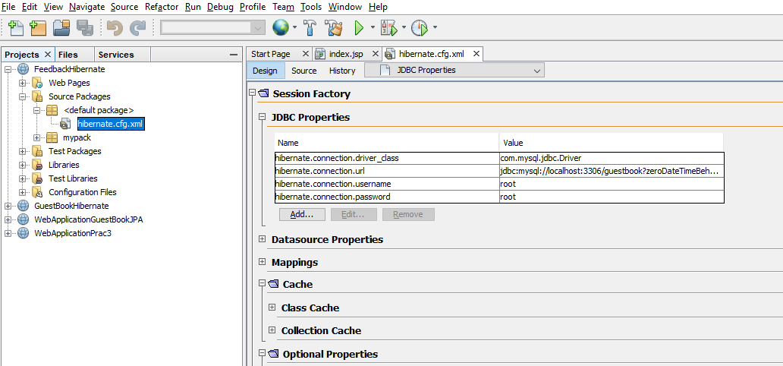

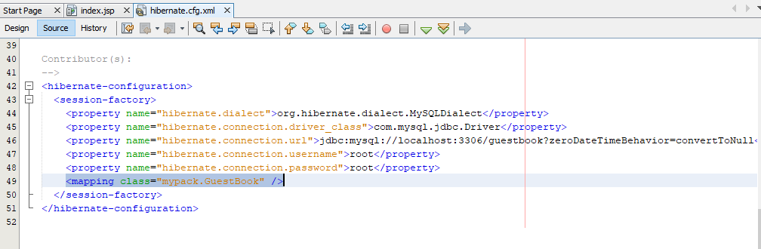

**The application has the following components**

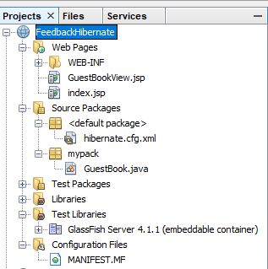 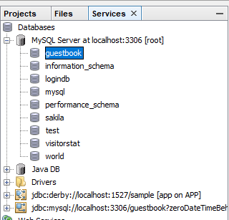

**File Name: GuestBook.java**

package mypack;

**import javax.persistence.*;**

**@Entity**

**@Table(name="guestbook.guestbook")**

public class GuestBook implements java.io.Serializable {

**@Id**

**@GeneratedValue**

**@Column(name="VisitorNo")**

**private Integer visitorNo;**

**@Column(name="VisitorName")**

**private String visitorName;**

**@Column(name="Message")**

**private String message;**

**@Column(name="MessageDate")**

**private String messageDate;**

**public GuestBook() {**

**}**

**public GuestBook(String visitorName, String message, String messageDate) {**

**this.visitorName = visitorName;**

**this.message = message;**

**this.messageDate = messageDate;**

**}**

**public Integer getVisitorNo() {**

**return visitorNo;**

**}**

**public void setVisitorNo(Integer visitorNo) {**

**this.visitorNo = visitorNo;**

**}**

**public String getVisitorName() {**

**return visitorName;**

**}**

**public void setVisitorName(String visitorName) {**

**this.visitorName = visitorName;**

**}**

**public String getMessage() {**

**return message;**

**}**

**public void setMessage(String message) {**

**this.message = message;**

**}**

**public String getMessageDate() {**

**return messageDate;**

**}**

**public void setMessageDate(String messageDate) {**

**this.messageDate = messageDate;**

**}**

}

**File Name: index.jsp**

<%@page contentType="text/html" pageEncoding="UTF-8"%>

<!DOCTYPE html>

<html>

<head>

<meta http-equiv="Content-Type" content="text/html; charset=UTF-8">

<title>JSP Page</title>

</head>

<body>

**Sign the Guest Book**

**<form action="GuestBookView.jsp" method="post">**

**Visitor Name: <input type="text" name="guest" /> <br>**

**Message: <textarea rows="5" cols="36" name="message">**

**</textarea> <br>**

**<input type="submit" name="btnSubmit" value="Submit" />**

**</form>**

</body>

</html>

**File Name: index.jsp**

**<%@page import="org.hibernate.service.ServiceRegistryBuilder"%>**

**<%@page import="java.util.*"%>**

**<%@page import="org.hibernate.service.ServiceRegistry"%>**

**<%@page import="org.hibernate.*"%>**

**<%@page import="org.hibernate.*, org.hibernate.cfg.*, mypack.*" %>**

<%@page contentType="text/html" pageEncoding="UTF-8"%>

<!DOCTYPE html>

**<%!**

**SessionFactory sessionFactory;**

**ServiceRegistry serviceRegistry;**

**org.hibernate.Session hibernateSession;**

**List<GuestBook> guestbook;**

**%>**

**<%**

**Configuration configuration = new Configuration();**

**configuration.configure();**

**serviceRegistry = new ServiceRegistryBuilder().applySettings(configuration.getProperties()).buildServiceRegistry();**

**sessionFactory = configuration.buildSessionFactory(serviceRegistry);**

**hibernateSession = sessionFactory.openSession();**

**Transaction transaction = null;**

**String submit = request.getParameter("btnSubmit");**

**if (submit != null && ("Submit").equals(submit)) {**

**GuestBook gb = new GuestBook();**

**try {**

**transaction = hibernateSession.beginTransaction();**

**String guest = request.getParameter("guest");**

**String message = request.getParameter("message");**

**String messageDate = new java.util.Date().toString();**

**gb.setVisitorName(guest);**

**gb.setMessage(message);**

**gb.setMessageDate(messageDate);**

**hibernateSession.save(gb);**

**transaction.commit();**

**} catch (RuntimeException e) {**

**if (transaction != null) {**

**transaction.rollback();**

**}**

**throw e;**

**}**

**response.sendRedirect("GuestBookView.jsp");**

**}**

**try {**

**hibernateSession.beginTransaction();**

**guestbook = hibernateSession.createQuery("from GuestBook").list();**

**} catch (RuntimeException e) {**

**throw e;**

**}**

**hibernateSession.close();**

**%>**

<html>

<head>

<meta http-equiv="Content-Type" content="text/html; charset=UTF-8">

<title>JSP Page</title>

</head>

<body>

**View the Guest Book <b>Click <a href="index.jsp"> here</a> to sign the guestbook.</b> <hr />**

**<%**

**Iterator iterator = guestbook.iterator();**

**while (iterator.hasNext()) {**

**GuestBook objGb = (GuestBook) iterator.next();**

**%>**

**On <%=objGb.getMessageDate()%>, <br />**

**<b><%=objGb.getVisitorName()%>: </b>**

**<%=objGb.getMessage()%> <br><br>**

**<%**

**}**

**%>**

</body>

</html>

**File Name: hibernate.cfg.xml**

<hibernate-configuration>

<session-factory>

<property name="hibernate.dialect">org.hibernate.dialect.MySQLDialect</property>

<property name="hibernate.connection.driver_class">com.mysql.jdbc.Driver</property>

<property name="hibernate.connection.url">jdbc:mysql://localhost:3306/guestbook?zeroDateTimeBehavior=convertToNull</property>

<property name="hibernate.connection.username">root</property>

<property name="hibernate.connection.password">root</property>

**<mapping class="mypack.GuestBook" />**

</session-factory>

</hibernate-configuration>

**Output:**

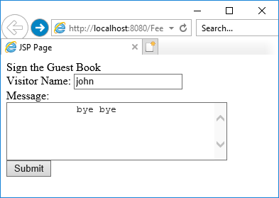 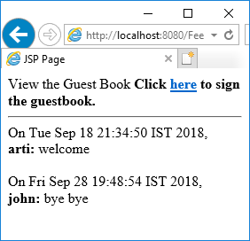

mysql> select * from guestbook;

+-----------+-------------+---------------------+------------------------------+

| VisitorNo | VisitorName | Message | MessageDate |

+-----------+-------------+---------------------+------------------------------+

| 1 | arti | welcome | Tue Sep 18 21:34:50 IST 2018 |

| 3 | john | bye bye | Fri Sep 28 19:48:54 IST 2018 |

+-----------+-------------+---------------------+------------------------------+